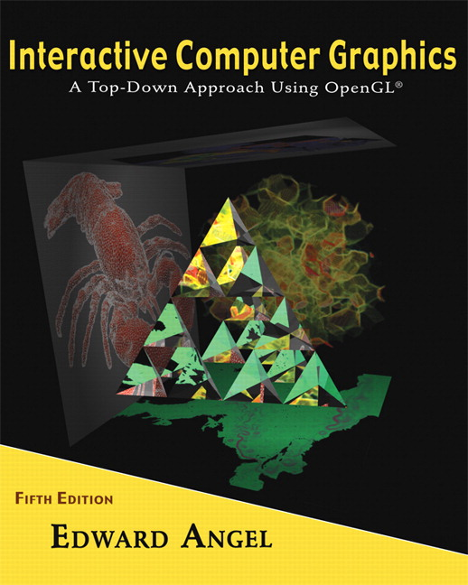

Name: ______________________ Terminal # ____

Programming Assignment 3
(100 points)

The Programming Assignment is to be turned in the first ten minutes of the due date class as:

Hardcopy (with your terminal #!)
Source Code and Screenshots that shows that your Visual Studio 2010 “Programming Assignment 3” PROJECT compiles and runs!

Electronic: Submit the Visual Studio2010 “Programming Assignment 3” zipped PROJECT to BB so you can run it in 200 PGH!

Origami JURASIC PARK - Summer 2013 Modeling Instructions
Let’s imagine the Jurassic Park being a cube of 12 X 12 X 12 “sitting on the base of the Jurassic Park ground thus y = 0 and the origin in the center of the park (on xy).

1. The glutCreateWindow OpenGL call will take as parameter “YourLastName JURASIC PARK Version 3”.
2. Start with the MyJURASIC PARK.c that you have created in Programming Assignment 2 and call the file LastNameJURASIC PARK.c.

3. Lighting and Shading:
Add 1 spot light initially located on the top front right of (right side looking at the JURASIC PARK looking from the FRONT) the JURASIC PARK, distance term a = 1, initial direction towards the center of the JURASIC PARK (y =0). You can use the coefficients from the Lecture 6 and the format from Homework 6 for the MaterialStruct.
You should allow the movement of the light source in 3 positions top front left, top back right, and top back left (basically the top 4 corners of the cube pointing towards the Jurassic Park center.
You should allow 2 changes of the angle of the light to 90 and 45 (default is 180).
The discrete reposition & orientation of the light should be linked to a menu main lights option and submenus.

4. Texturing:
Texture your JURASIC PARK by using either a texture similar to the actual JURASIC PARK or any other JURASIC PARK siding textures or bump mapping.
If you have several texturing, create a menu main textures option to use all of them. I guess this could be the extra credit problem. (20 points)

Get screenshots of the “YourLastName JURASIC PARK Version 3” for each view and please comment on what the screenshot is about.

